**Curriculum Vitae**

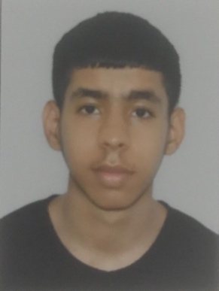Please contact ma at

**Mobile:** +973-35103160

**E-mail:** [baqer.mohamed313@gmail.com](mailto:baqer.mohamed313@gmail.com)

**Address:** Villa 1778

Road 8318

Block 583

**Personal Information :**

**Name:**  Baqer Mohamed Redha Abbas

**CPr:** 010906223

**Passport No**: 2931882

**Nationality:** Bahraini

**Date of Bairth:** 19th Septemper 2001

**Marital Status:** Single

**Current education a qualifications :**

**2019-JUN** Completes the secondary school education with degree of C

Educational experience and participation :

**2014-DEC** He won the golden medal in the Handball League

**2015-FEB** Volunteered to teach children's how to pray

**2018-SEP** OJT training program at Ebrahim K.Kanoo